**GENERATION OF DISCRETE TIME SIGNALS**

Ms. Soumya G., USN-1DS17EC158, Ms. Namratha Sridhar, USN-1DS17EC154

Ms. Vandana G., USN-1DS17EC155, Mahek Mitare, USN-1DS17EC059

IV Sem ECE Students, DSCE, Bangalore, Karnataka

Email : soumya221999@gmail.com, namrathasridhar2603@gmail.com, vandanagajendra@gmail.com, mahekrmithare@gmail.com

Phone : 9210651838 9621430672 9235704843 8861099805

Mr. Rajesh S.M., Asst. Prof., ECE, DSCE, Bangalore

Email : hgrajeshkumar@gmail.com Mob : 8050565568

***Abstract –*** In this research paper presented in the form of an abstract, generation of different types of discrete time signals is presented such as impulse, sine, cos, exponential, ramp, step. Matlab is being used to generate the different types of discrete time signals. Codes are written as .m files, the developed code is run after giving the input variables & the output waveforms are observed. A DT signal x(n) is a signal which is obtained by the sampling of a CT signal x(t) & this done by the process of sampling. Basically, sampler is a switch which is opened & closed at regular intervals of time. The input to the sampler is a CT signal & the output of the sampler is a DT signal, which has got different levels & the amplitude depends on the time at which the switch is closed to the signal. An exercise is being carried out in this context after studying the theoretical aspects of the DT case. All the elementary signals such as the ones mentioned above are discretized using the process of sampling using a simulation study & the results are observed. The end result – “In discrete time signal, the value of the signal is specified only at a specific time. So signal represented at “discrete interval of time” is called as a discrete time signal.” Hence, different types of discrete type of signals are studied and simulated using Matlab, which is the highlight of this paper. The theory of discrete-time signals and systems to three important areas: digital signal processing, digital control, and digital communications. It discusses how the theoretical results related to digital signal processing, digital control, and digital communications. Due to advances in digital technologies and computers, processing of signals is being done digitally. Early results in sampling, analog-to-digital conversion, and the fast computation of the output of linear systems using the Fast Fourier Transform (FFT), made it possible for digital signal processing to become a technical area on its own. The fast Fourier transform made possible the establishment and significant growth of digital signal processing as a technical area. The theory of sampled data shows the connection between the Laplace and the Z-transform. The difficulty in the analysis of these systems is the mixing of continuous and discrete-time signals. Digital communication systems provide a more efficient way to communicate information than analog communication systems, but they are more demanding in terms of bandwidth. Efficient use of the radio spectrum and efficient processing has become the objectives of modern wireless communication systems such as spread spectrum and orthogonal frequency-division multiplexing.

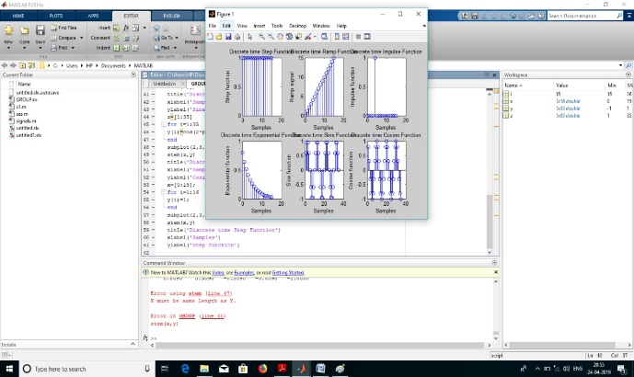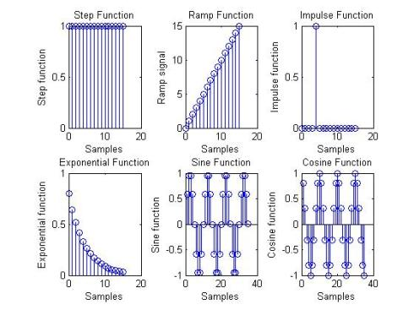

***Keywords -*** DT, CT, Sampling, Discrete, Continuous, Sample, ZT, LT, FT,